Sectoral Policies Department
Transport and Maritime Unit (MARITRANS)
Publications and other ILO tools concerning the Work in Fishing Convention, 2007 (No. 188)
C188 - Work in Fishing Convention, 2007 (No. 188)
Convention concerning work in the fishing sector (Entry into force: 16 Nov 2017)
Adoption: Geneva, 96th ILC session (14 Jun 2007) - Status: Up-to-date instrument (Technical Convention).
The Work in Fishing Convention (C188) sets the basic standards of decent work in the fishing industry. C188 sets out binding requirements to address the main issues concerning work on board fishing vessels, including accommodation and food; conditions of service; occupational safety and health; social security and medical care. States that ratify the Convention commit to exercising control over fishing vessels through inspection, reporting, monitoring, complaint procedures, penalties and corrective measures.

Details and background resources on the process of the making and implementation of C188 may be found on the ILO website.

The following documents supplement the Convention 188, they provide descriptions of tools the ILO have to assist in the implementation and ratification of the Convention.
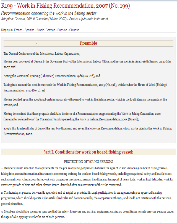  R199 - Work in Fishing Recommendation, 2007 (No. 199) |  |  |  |  | The Convention is supplemented by the accompanying Work in Fishing Recommendation (No. 199). The Recommendation provides guidelines on how best to implement the provisions of C188 offering more detailed advice on good practice. It also covers conditions of work on board fishing vessels, conditions of service, accommodation and medical care, health protection and social security.
This tool is designed to promote a greater comprehension of the Convention amongst ILO constituents. The topics addressed include the scope of C188`s application, the unique flexibility mechanisms for its implementation, and explanations about the advantages of the Convention for fishers, fishing vessels owners, and ILO member States. |  |  |  |  |  |  |  |  |  |  | 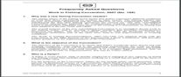  Frequently Asked Questions: Work in Fishing Convention, 2007 (No. 188) - 2012
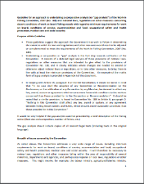  Guideline to undertake a comparative analysis of the Work in Fishing Convention, 2007 (No. 188) - 2011 |  |  |  |  |  | These guidelines recommend that Governments undertake a comparative or “gap” analysis to examine the extent to which national regulations and laws would need to be complemented or adjusted, in order to meet the requirements of C188. This “gap” analysis is the first step towards the ratification of the Convention.
This working paper outlines the flexibility clauses of C188 with a view to assisting those considering making use of these clauses when ratifying and implementing the Convention. The flexibility allows for member States to adapt the application of the Convention to national circumstances, as maybe necessary, and gradually achieve the goal of universal coverage. |  |  |  |  |  |  |  |  |  |  |  |  | 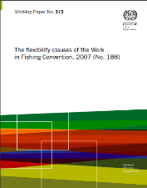  The flexibility clauses of the Work in Fishing Convention, 2007 (No. 188) - 2017
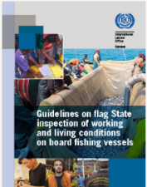  Guidelines on flag State inspection of working and living conditions on board fishing vessels - 2017 |  |  |  |  |  | The Guidelines aims to provide flag States with supplementary practical information and guidance that can be adapted to reflect national laws and other measures through which Convention No. 188 is implemented. The Guidelines include chapters on the key concepts and contents of C188, on flag State inspection systems for the fishing sector. Further, it provides guidance on coordination with enforcement measures related to violations of fundamental principles and rights at work (i.e. forced labour).
The Guidelines outline the port State control responsibilities under C188. They aim to assist port State control officers through the provision of proper guidelines for the performance of their duties. They examine all aspects of conducting port State inspections and address basic requirements, indicative sources of information and examples of non-conformities for specific inspection areas. |  |  |  |  |  |  |  |  |  |  |  | 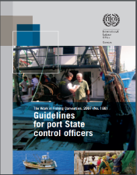  Guidelines for Port State Control Officers Carrying out Inspections under the Work in Fishing Convention, 2007 (No.188) - 2012
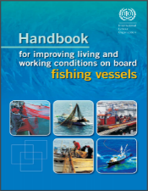  Handbook for improving living conditions on board fishing vessels - 2010 |  |  | This handbook intends to assist competent authorities, representative organizations of workers and employers, as well as other relevant stakeholders, to gain a more comprehensive understanding of the C188 and Recommendation No. 199. The Handbook is a useful tool for reviewing and improving existing legal protection mechanisms.
The issue paper was prepared by the ILO as a basis for discussion at the Global Dialogue Forum for the promotion of C188. The Forum discussed challenges in the implementation of C188, reported on and reviewed promotional activities, evaluating how the C188 can be used as a tool to address major challenges in the industry. |  |  |  |  |  |  |  |  |  |  |  |  |  |  |  | 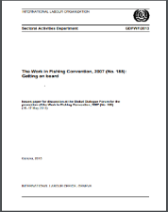  The Work in Fishing Convention, 2007: Getting on board – 2013
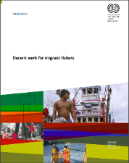  Decent work for migrant fishers – 2017 |  | This report provides a basis for the discussion at the Tripartite Meeting on issues relating to Migrant Fishers. It reviews living and working conditions in the sector. This report details the issues faced by migrant fishers, including the opportunities and challenges of unacceptable conditions of work and severe abuse in the sector. It also details international labour standards of the ILO, that may be relevant to improving the conditions of migrant fishers.
This report reviews and consolidates existing knowledge on forced labour and human trafficking in fisheries, with emphasis on fishing vessels in commercial marine fisheries. It considers legal and institutional as well as multi-stakeholder initiatives having the potential to impact living, working and safety conditions of fishers. This is done with the aim to consider the main issues that inform the discussion on how to move forward in addressing forced labour and human trafficking issues. |  |  |  |  |  |  |  |  |  |  |  |  |  |  | 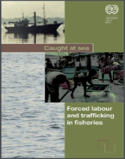  Caught at Sea - Forced Labour and Trafficking in Fisheries - 2012
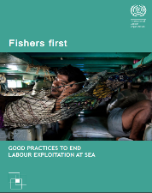  Fishers first  Good practices to end labour exploitation at sea – 2016 |  | This report focuses on innovative interventions and good practices to improve labour conditions and protect vulnerable workers in the fisheries sector. The report contributes to the on- going efforts to combat Illegal, Unregulated and Unreported (IUU) fishing and to address decent work deficits in the sector. The report contains multiple examples of the ILO’s work to support the application of standards, whether ratified or not, among member States.

The ILO aims to combat forced labour, trafficking in persons and other unacceptable forms of work in the fishing sector through development cooperation projects. Such projects include the EU-funded Ship to Shore Rights Project addresses issues related to fundamental principles and rights at work in the fishing sector in Thailand and the US-funded regional SEA Fisheries project, which tackles the issue of trafficking in persons in the ASEAN States.

For more information on the work of the ILO in Fisheries visit ILO website

