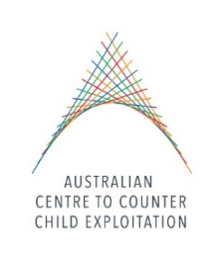

PROTECTING CHILDREN FROM FOREIGN CHILD SEX OFFENDERS

KEY CONTACTS
Name | Agency | Email
Senior Liaison Officer Naomi Binstead | Australian Federal Police (AFP) Phnom Penh | Naomi.Binstead@afp.gov.au
Detective Sergeant Jarryd Dunbar | Australian Federal Police (AFP) Sydney | Jarryd.Dunbar@afp.gov.au
Federal Agent Paul Onken – Social Media Advisor | Australian Federal Police (AFP) Manila | Paul.Onken@afp.gov.au
Peter Hancox – Cybercrime Advisor | Australian Federal Police (AFP) Jakarta | Peter.Hancox@afp.gov.au
Liaison Officer Joseph Thorn | Australian Federal Police (AFP) Bangkok | Joseph.Thorn@afp.gov.au
Napol (Teddy) Woraprateep | Thailand DSI | napol.wo@gmail.com
Patrick Tidmarsh | Victoria Police | patrick.tidmarsh@police.vic.gov.au
Detective Inspector Farid El Hamouti | Netherlands Police | farid.elhamouti@minbuza.nl
His Excellency Hor Sorun | Ministry of Tourism | horsarun168@gmail.com
Russell Bash | Homeland Security Investigations (HSI) Phnom Penh | russell.bash@ice.dhs.gov
Scott Schofield | Federal Bureau of Investigations (FBI) Phnom Penh | saschofield@fbi.gov
Police Captain Yong Chanwathanak | General Department of Immigration | yongchanwathanak22@gmail.com
Khoem Vando | APLE | K.vando@aplecambodia.org
Anita Dodds | N/A | anita_stuart@hotmail.com

